# DAD 220 Database Documentation

Neelima Patnaik

10/09/2020

Complete these steps as you work through the directions for Project One. Replace the bracketed text with your screenshots and brief explanations of the work they capture. Each screenshot and its explanation should be sized to approximately one quarter of the page, with the description written below the screenshot. Follow these rules for each of the prompts and questions below. Review the example document located in the Project One Supporting Materials for assistance.

## Step One: Create a Database

1. Navigate to your online integrated development environment (IDE). Here, you will need to write the proper SQL commands in command line to create tables that demonstrate relationships based on the entity relationship diagram. List and record the SQL commands that you used to complete this step here:

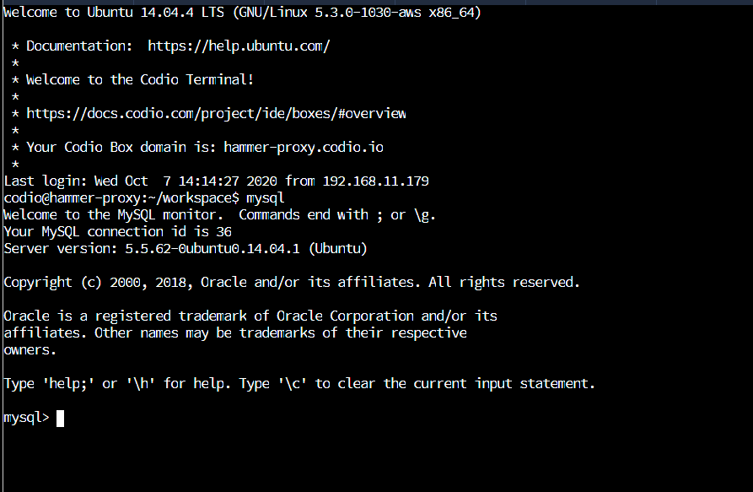

1. Create a database schema called *QuantigrationUpdates*. List out the database name. Provide the SQL commands you ran against MySQL to successfully complete this in your answer:

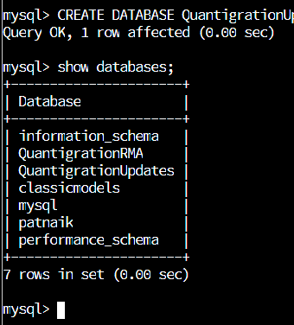

1. Using the ERD as a reference, **create the following tables with the appropriate attributes and keys**:
   1. A table named **customers** in the *QuantigrationUpdates* database as defined on the project ERD. Provide the SQL commands you ran against MySQL to complete this successfully in your answer:



CREATE TABLE Customers (

CustomerID INT,

FirstName VARCHAR(25),

LastName VARCHAR(25),

Street VARCHAR(50),

City VARCHAR(50),

State VARCHAR(25),

ZipCode INT,

Telephone VARCHAR(15),

PRIMARY KEY(CustomerID)

);

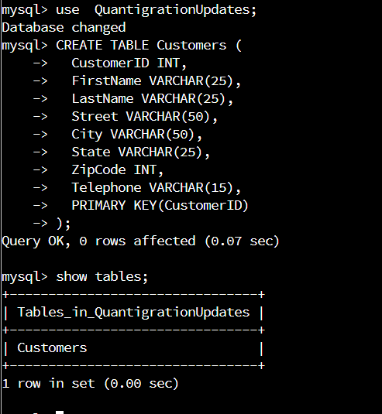

* 1. A table named **orders** in the *QuantigrationUpdates* database as defined on the project ERD. Provide the SQL commands you ran against MySQL to complete this successfully in your answer:

CREATE TABLE Orders (

OrderID INT,

CustomerID INT,

SKU VARCHAR(20),

Description VARCHAR(50),

PRIMARY KEY(OrderID)

);

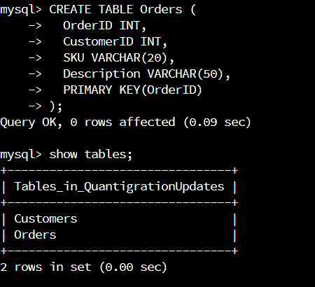

* 1. A table named **rma** in the *QuantigrationUpdates* database as defined on the project ERD. Provide the SQL commands you ran against MySQL to complete this successfully in your answer:

CREATE TABLE RMA (

RMAID INT,

OrderID INT,

Reason VARCHAR(25),

Status VARCHAR(50),

Step VARCHAR(15),

PRIMARY KEY(RMAID)

);

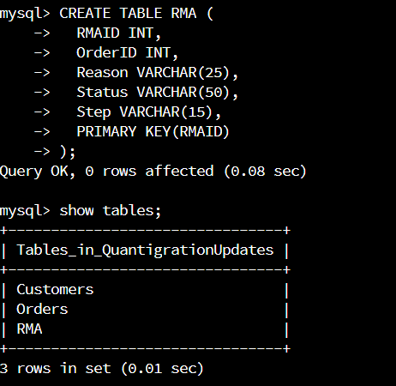

1. **Update your existing table** from “Customer” to “Collaborator” using SQL based on this change in requirements. Provide the SQL commands you ran against MySQL to complete this successfully in your answer:

ALTER TABLE Customers

RENAME TO Collaborator;

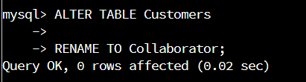

## Step Two: Load and Query the Data

1. **Import the data from each file into tables**.
   * Use the *QuantigrationUpdates* database, the three tables you created, and the three CSV files preloaded into Codio.
   * Use the import utility of your database program to load the data from each file into the table of the same name. You will perform this step three times, once for each table.

LOAD DATA INFILE '/home/codio/workspace/rma.csv' INTO TABLE RMA FIELDS TERMINATED BY ',' LINES TERMINATED BY '\r\n';



LOAD DATA INFILE '/home/codio/workspace/orders.csv' INTO TABLE Orders FIELDS TERMINATED BY ',' LINES TERMINATED BY '\r\n';



LOAD DATA INFILE '/home/codio/workspace/customers.csv'

INTO TABLE Customers

FIELDS TERMINATED BY ','

LINES TERMINATED BY '\r\n';



1. **Write basic queries against imported tables to organize and analyze targeted data.** For each query, replace the bracketed text with a screenshot of the query and its output. You should also include a brief, 1- to 3-sentence description of the output.
   * Write an SQL query that returns the count of orders for customers located only in the city of Framingham, Massachusetts.
     1. How many records were returned?

SELECT COUNT(*)

FROM Customers INNER JOIN Orders ON Customers.CustomerID = Orders.CustomerID

WHERE UPPER(Customers.city) = "FRAMINGHAM" AND UPPER(Customers.state) = 'MASSACHUSETTS';

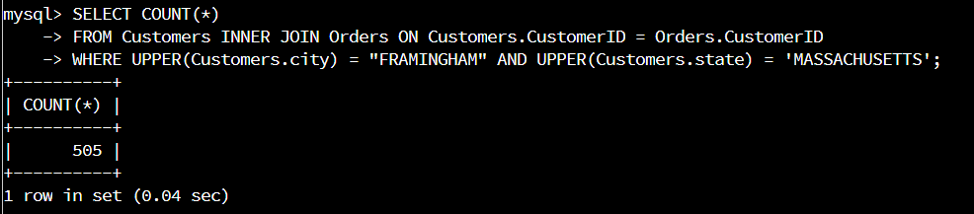

Total 505 records were returned.

* + Write an SQL query to select all of the customers located in the state of Massachusetts.

SELECT COUNT(*)

FROM Customers INNER JOIN Orders ON Customers.CustomerID = Orders.CustomerID

WHERE UPPER(Customers.state) = 'MASSACHUSETTS';

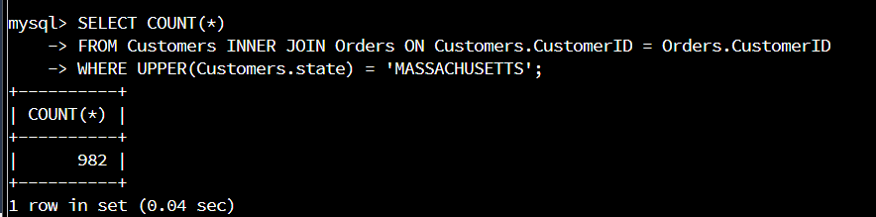

There are 982 customers located in the state of Massachusetts.

* + Write a SQL query to insert four new records into the orders and customers tables using the following data:
    1. Customers Table

INSERT INTO Customers (CustomerID, FirstName, LastName, Street, City, State, ZipCode, Telephone)

VALUES

(100004, 'Luke', 'Skywalker', '17 Maiden Lane', 'New York', 'NY', 10222, '212-555-1234'),

(100005, 'Winston', 'Smith', '128 Sycamore Street', 'Greensboro', 'NC', 27401, '919-555-6623'),

(100006, 'MaryAnne', 'Jenkins', '2 Coconut Way', 'Jupiter', 'FL', 33458, '321-555-8907'),

(100007, 'Janet', 'Williams', '58 Redondo Beach Blvd', 'Torrence', 'CA', 90501, '310-555-5678');

|  |  |  |  |  |  |  |  |
| --- | --- | --- | --- | --- | --- | --- | --- |
| **CustomerID** | **FirstName** | **LastName** | **StreetAddress** | **City** | **State** | **ZipCode** | **Telephone** |
| 100004 | Luke | Skywalker | 15 Maiden Lane | New York | NY | 10222 | 212-555-1234 |
| 100005 | Winston | Smith | 123 Sycamore Street | Greensboro | NC | 27401 | 919-555-6623 |
| 100006 | MaryAnne | Jenkins | 1 Coconut Way | Jupiter | FL | 33458 | 321-555-8907 |
| 100007 | Janet | Williams | 55 Redondo Beach Blvd | Torrence | CA | 90501 | 310-555-5678 |

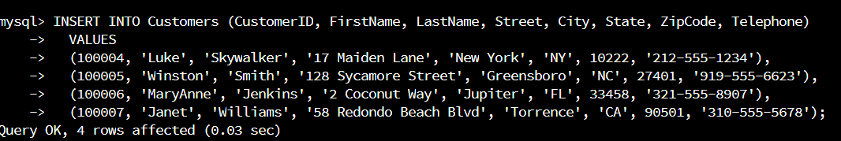

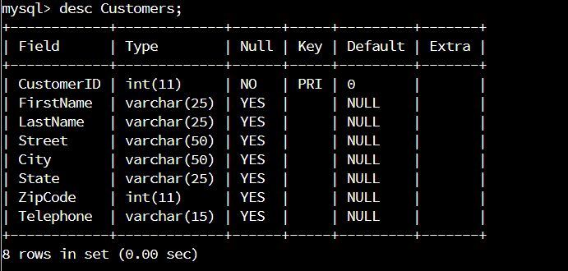

* + 1. Orders Table

INSERT INTO Orders (OrderID, CustomerID, SKU, Description)

VALUES

(1204305, 100004, 'ADV-24-10C', 'Advanced Switch 10GigE Copper 24 port'),

(1204306, 100005, 'ADV-48-10F', 'Advanced Switch 10GigE Copper/Fiber 44 port copper 4 port fiber'),

(1204307, 100006, 'ENT-24-10F', 'Enterprise Switch 10GigE SFP+ 24 Port'),

(1204308, 100007, 'ENT-48-10F', 'Enterprise Switch 10GigE SFP+ 48 Port');

|  |  |  |  |
| --- | --- | --- | --- |
| **OrderID** | **CustomerID** | **SKU** | **Description** |
| 1204305 | 100004 | ADV-24-10C | Advanced Switch 10GigE Copper 24 port |
| 1204306 | 100005 | ADV-48-10F | Advanced Switch 10 GigE Copper/Fiber 44 port copper 4 port fiber |
| 1204307 | 100006 | ENT-24-10F | Enterprise Switch 10GigE SFP+ 24 Port |
| 1204308 | 100007 | ENT-48-10F | Enterprise Switch 10GigE SFP+ 48 port |

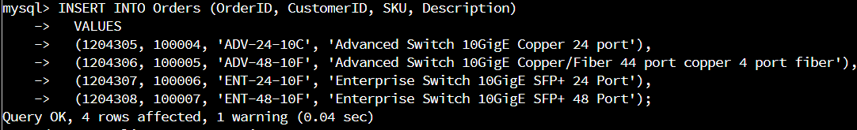

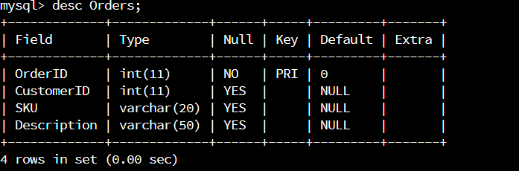

* + In the customers table, perform a query to count all records where the city is Woonsocket, Rhode Island.
    1. How many records are in the customers table where the field “city” equals “Woonsocket”?

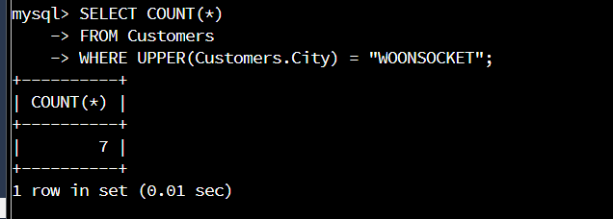

There are 7 customers from the city Woonsocket.

* + In the rma database, update a customer’s records.
    1. Write an SQL statement to select the current fields of *status* and *step* for the record in the *rma* table with an *orderid* value of “5175.”

SELECT Status, Step

FROM RMA

WHERE UPPER(RMA.OrderID) = "5175";

UPDATE RMA

SET

Status = 'Complete',

Step = 'Credit Customer Account'

WHERE UPPER(RMA.OrderID) = "5175";

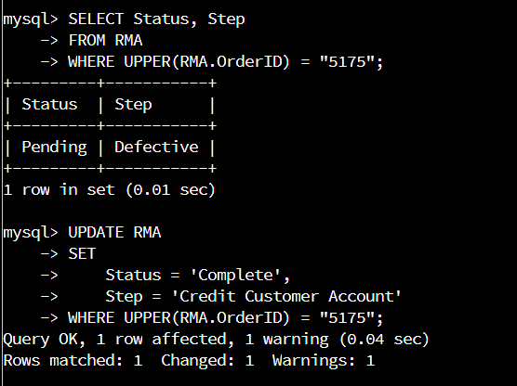

* + 1. Write an SQL statement to update the *status* and *step* for the *orderid*, 5175 to *status* = “Complete” and *step* = “Credit Customer Account.”

What are the updated *status* and *step* values for this record?

SELECT Status, Step

FROM RMA

WHERE UPPER(RMA.OrderID) = "5175";

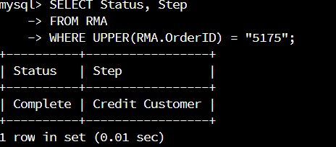

* + Delete rma records.
    1. Write an SQL statement to delete all records with a reason of “Rejected.”
       1. How many records were deleted?

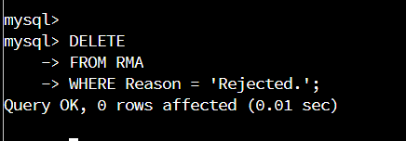

It shows that 0 rows effected this means none deleted.

1. **Create an output file of the required query results.** Write an SQL statement to list the contents of the *orders* table and send the output to a file that has a .csv extension.

I created the output csv file orders-output.csv in the workspace directory. Please see screenshots below

